## Modulette_rubrics table

## Fields

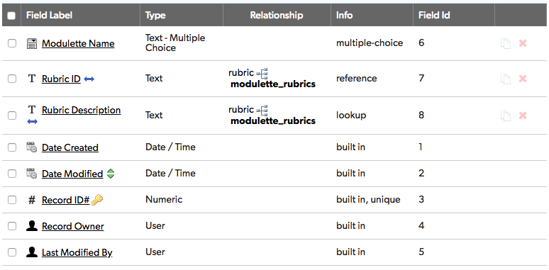

## Relationships

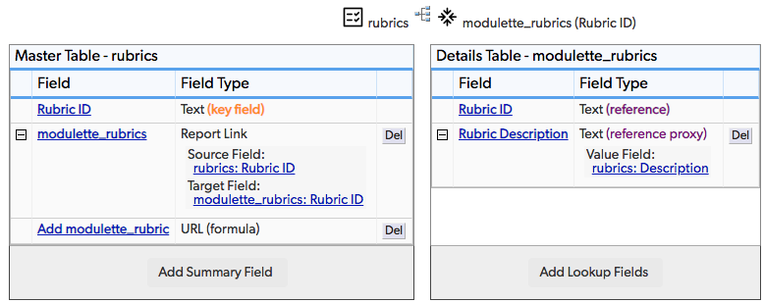

## Field settings

Note: Built-in fields use the default settings

Modulette Name 3

Rubric ID 5

Rubric Description 6

# Modulette Name

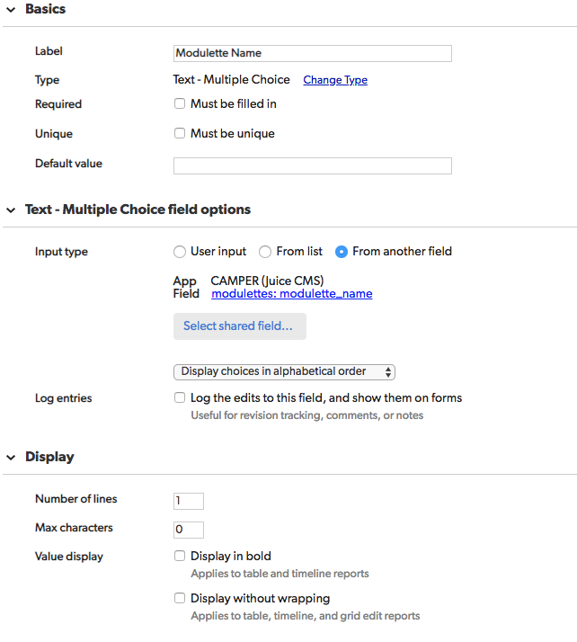

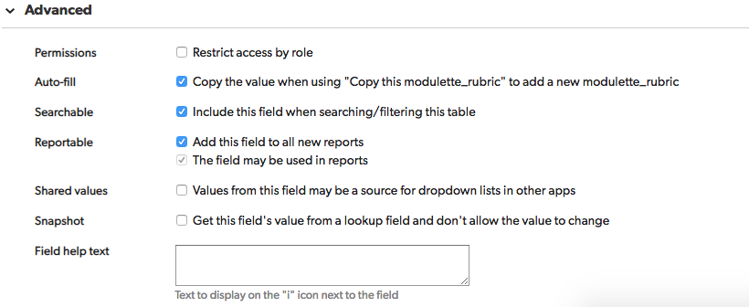

# Rubric ID

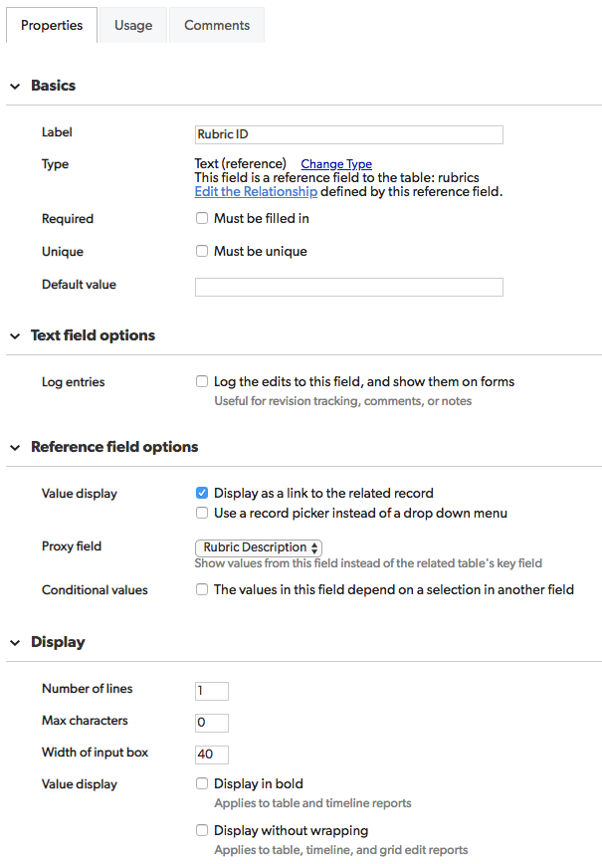

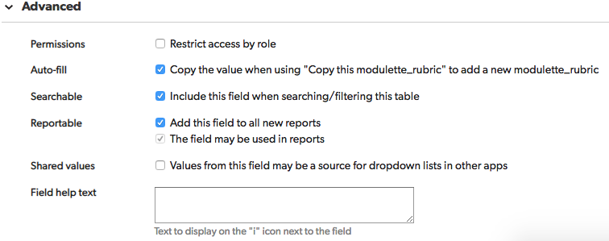

# Rubric Description

